**Wireframe**

**Insurance Premium Prediction**

Revision Number – 1.0

# Last Date of Revision: 14 – 05 -2023

Santhana Lakshmi

**Document Version Control**

|  |  |  |  |
| --- | --- | --- | --- |
| Date | Version | Description | Author |
| 14– 05 - 2023 | 1.0 | First Draft | Santhana Lakshmi |

Contents

1. Landing Page
2. Prediction Results

**1.Landing Page**

Insurance Premium Prediction Homepage is deployed using Streamlit framework. Landing Page have 6 features Age, Sex, BMI, No of Children, Smoker or not, Region and Predict button to predict the premium.

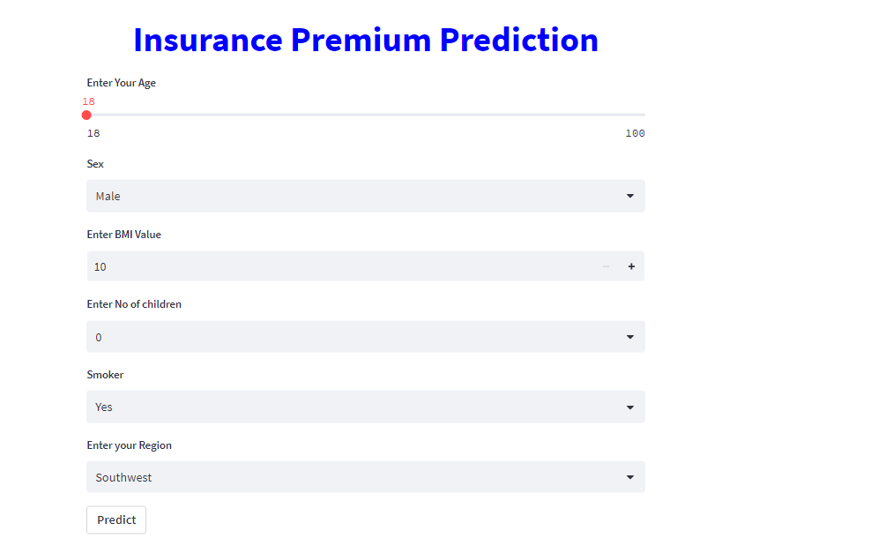

**2.Prediction Results**

User provides all the information and then clicks on predict button. The predicted result displays.

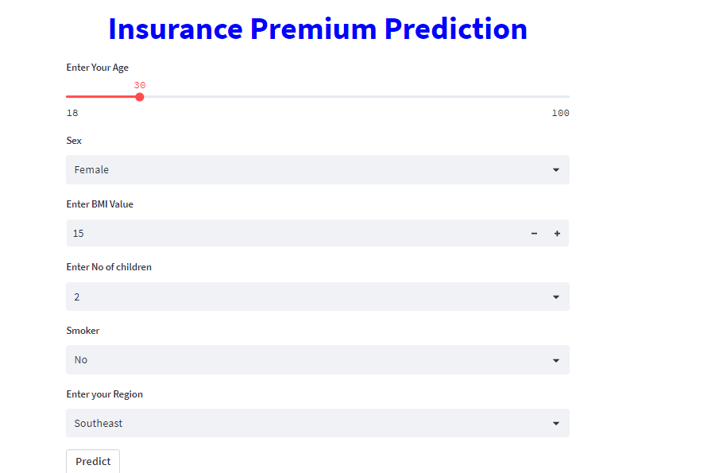

**Predicted Premium:**

